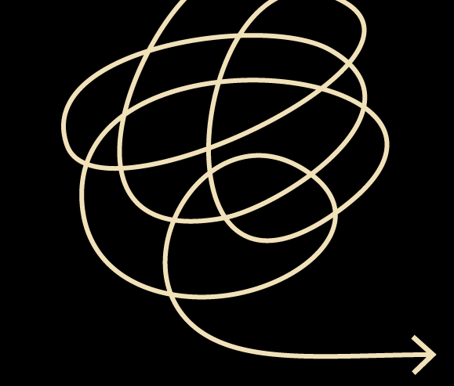  Style sheet  Use this template to record the style choices you make when you write. This will keep your writing consistent.  Add to, or replace, the text with your own style choices.  Click here for more tips on creating a style sheet |  | Title of my document  Sources  Macquarie Online Dictionary  NZ Government online style guide  Language  Spelling: English rather than American (organise, colour)  Contractions: yes (can’t)  Numbers  In text: one to nine in words; 10 and above in figures, unless used in a general sense (about a hundred people); 10,000 and above separated with commas (60,000, 850,000); spell out million and billion (three million, 10 billion)  In tables and figures: use figures  In ages: nine-year-old boy, 16-year-old girl; the boy is nine years old, the girl is 16 years old  Percentages  In text: 6 percent, 20 percent  In tables and figures: 6%, 20%  Fractions: spell out and hyphenate (three-quarters)  Measurements  In text: 5 centimetres, unless used in a general sense (hundreds of miles)  In tables and figures: 5cm  Currency  USD 1000, GBP 15,000m NZD 2 billion, AUD 500,000  Dates and times  18 August 2018  10.15 am, 2.20 pm, 12 noon, 12 midnight  1970s, 1980s  eighteenth century  Abbreviations  Acronyms: no full stops (CD, GNP, USA)  Contractions ending with the same letter as the original word: no full stops (Mr, Dr)  Abbreviations that do not include the last letter of the word: use full stop (ed., ch.)  Initials: use spaces but no full stops (H B Bradford)  Etc, ie and eg: replace with plain alternatives (and so on, that is, for example)  Punctuation  Em dash (—) with a space either side: marks a sudden break of thought or adds emphasis  En dash (–) with no spaces: separates numbers (pages 12–14) and dates (2005–2015)  Quotations: single quotation marks with double for quotes within quotes. Indent quotations longer than four lines and do not use quotation marks. No italics for quotations  Commas: no serial comma unless it aids clarity (I like apples, pears and lemons)  Typography  Bold: use sparingly to add emphasis  Italics: use for titles of publications and for foreign words (not for te reo Māori)  Underline: use only with URLs  Parts of the document  Title: title case and no full stop  Headings and subheadings: sentence case and no full stop  Table caption: set above table. Table number. Caption. (Source)  Figure caption: set below figure. Figure number. Caption. (Source)  Notes and references  References: APA 7th author-date referencing style for facts, publications, quotations and sources of tables and figures  Reference list: set on new page at end of document  Explanatory notes: use endnotes. Separate endnotes by section for long documents  Alphabetical list  Choices about spelling, plurals, hyphenation, capitalization, abbreviations and italics  A–D E–H  cost-effective decision-making gender-based violence healthcare  I–L M–P  interrelated (one word) KickStart (new job programme) OECD (not spelt out) percent (not per cent)  Q–T U–Z  Sanitation Advisory Group (SAP) setup wellbeing wi-fi

